1. Problem Statement
The problem is to predict whether a passenger aboard the RMS Titanic survived the disaster of April 15, 1912, based on personal characteristics such as age, sex, ticket class, fare paid, cabin location, and family relationships.
The Titanic dataset is one of the most well-known introductory machine-learning benchmarks. It was originally published as a Kaggle competition (kaggle.com/c/titanic). The training set contains 891 labelled passengers; the test set contains 418 passengers whose survival is to be predicted. A sample submission file (gender_submission.csv) provides ground-truth labels for the test set, enabling us to calculate held-out accuracy.
The core challenge is that the dataset contains missing values (Age is absent for ~20 % of passengers, Cabin for ~77 %), correlated features (Pclass and Fare are strongly linked), and class imbalance (only 38 % of passengers survived). Effective feature engineering and a robust model are required to achieve good predictive performance.

2. Problem Categorisation

2.1 Supervised vs Unsupervised
This is a SUPERVISED learning problem. The training set provides a labelled target variable, Survived (0 = did not survive, 1 = survived), for each passenger. The model learns a mapping from input features to this binary label.

2.2 Classification vs Regression
This is a CLASSIFICATION problem. The target variable is discrete and binary: a passenger either survived (class 1) or did not (class 0). There is no meaningful ordering or continuous range to predict.

2.3 Online vs Batch Learning
This is a BATCH (offline) learning problem. The entire training dataset is available upfront, and the model is trained in a single pass over all examples. There is no streaming data source requiring incremental learning. If new passenger data were received continuously, an online approach might be considered, but this is not required here.

2.4 Summary Table
Dimension | Category
Learning paradigm | Supervised
Prediction type | Binary Classification
Training mode | Batch (offline)

3. Summary of Data Analyses and Results

Analysis 1 – Statistical Summary
A descriptive statistics summary was computed for all numeric columns using pandas .describe(). Key findings:
- 891 passengers in the training set; 418 in the test set.
- Survived: mean = 0.384 → only 38.4 % of training passengers survived.
- Age: mean ≈ 29.7 years, range 0.42–80; 177 missing values (19.9 %).
- Fare: heavily right-skewed; mean ≈ £32.20, max £512.33 (1st-class suites).
- Cabin: 687 missing values (77.1 %); dropped from model features.
The missing-value analysis guided the ETL strategy: Age was imputed with the median (robust to outliers); Embarked (2 missing) with the mode; Cabin was dropped entirely.

Analysis 2 – Histograms of Numeric Features
Histograms were plotted for Age, Fare, SibSp, and Parch with a vertical red line indicating the mean.
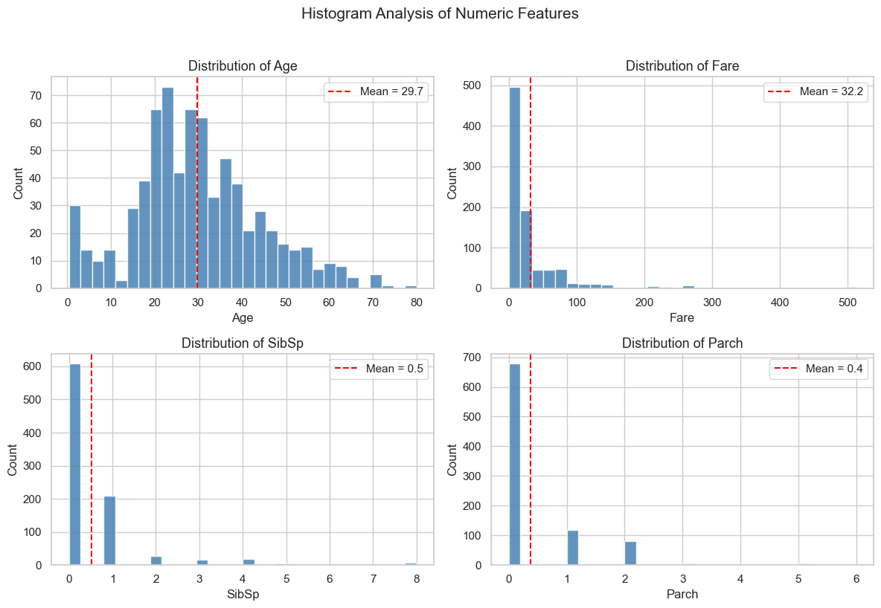
- Age follows an approximately normal distribution with a slight right tail and a spike of young children (ages 0–5).
- Fare is extremely right-skewed; most passengers paid under £50, but a handful in 1st class paid over £200.
- SibSp and Parch are highly concentrated at 0: most passengers travelled alone or with one companion.

Analysis 3 – Survival Rate by Categorical Feature
Bar charts show the percentage of survivors within each category of Sex, Pclass, and Embarked.
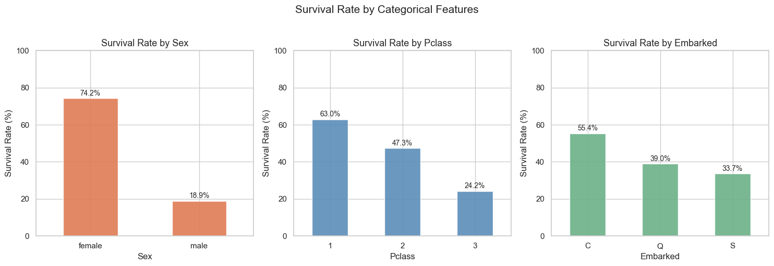
- Sex: 74.2 % of women survived vs only 18.9 % of men – the strongest single predictor ("women and children first" policy).
- Pclass: 62.9 % survival in 1st class, 47.3 % in 2nd class, 24.2 % in 3rd class – wealth and cabin location were decisive.
- Embarked: passengers who boarded at Cherbourg (C) had a 55.4 % survival rate vs 33.7 % (S) and 38.9 % (Q), partly because more 1st-class passengers boarded at Cherbourg.

Analysis 4 – Correlation Heatmap
A Pearson correlation heatmap was computed for all numeric variables.
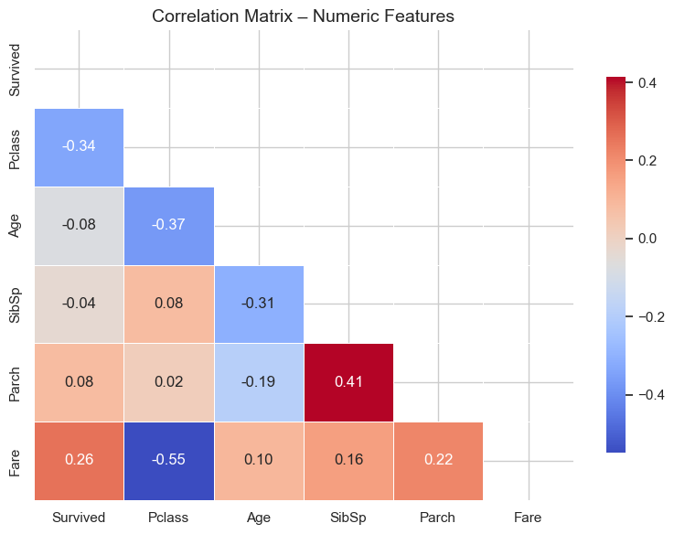
- Pclass vs Survived: r = −0.34 (strongest negative correlation; lower class number means higher class and higher survival).
- Fare vs Survived: r = +0.26 (higher fare → higher survival, consistent with class effect).
- Age vs Survived: r = −0.08 (slight negative; older passengers less likely to survive, but the effect is weak at the linear level).
- Fare vs Pclass: r = −0.55 (not surprising: 1st-class passengers paid more).

Analysis 5 – Age Distribution by Survival (Box Plot & KDE)
Box plots and Kernel Density Estimate (KDE) curves were used to compare the age distributions of survivors and non-survivors.
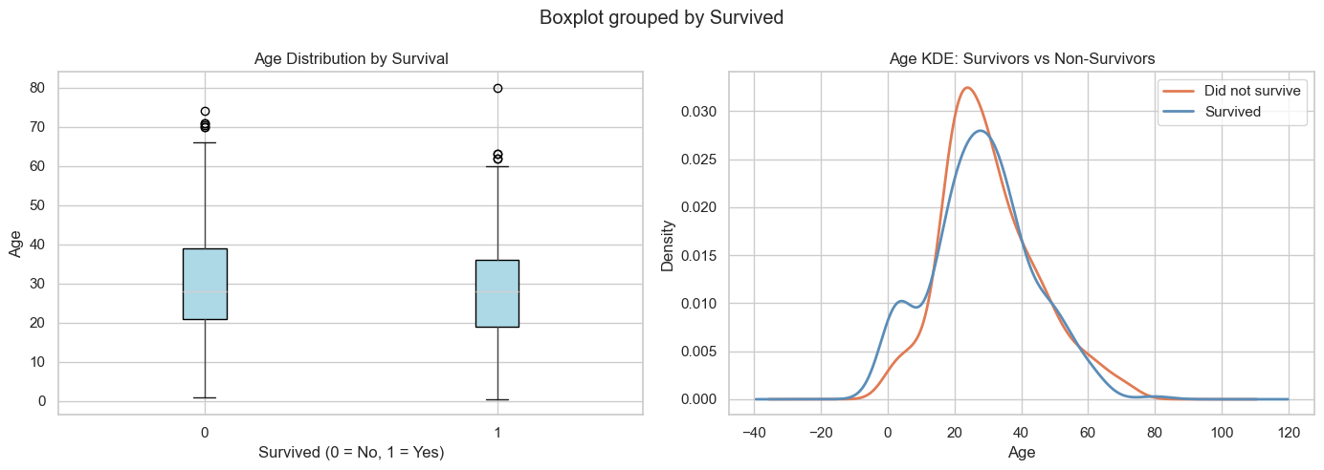

- Non-survivors (orange): median age ≈ 28; distribution skewed toward young adult males who faced the worst odds.
- Survivors (blue): median age ≈ 27; noticeably higher density at ages 0–10, confirming that children were prioritised for lifeboats.
- The KDE shows two peaks for survivors: infants/toddlers and young women (20–35).

4. ETL – Data Cleaning & Feature Engineering
The following transformations were applied to both train and test sets:
- Imputed missing Age values with the median (robust to outliers).
- Imputed 2 missing Embarked values with the mode ("S").
- Filled 1 missing Fare value in the test set with the median.
- Dropped Cabin (>77 % missing), Name, Ticket, and PassengerId.
- Created FamilySize = SibSp + Parch + 1.
- Created IsAlone flag = 1 if FamilySize == 1, else 0.
- Label-encoded Sex (female=0, male=1) and Embarked (C=0, Q=2, S=1).
Final feature set: Pclass, Sex_enc, Age, Fare, FamilySize, IsAlone, Embarked_enc.

5. Model Training & Accuracy

5.1 Models Used
Two classifiers were trained and compared:
- Logistic Regression (baseline linear model, max_iter=1000).
- Random Forest Classifier (200 trees, max_depth=6, random_state=42).

5.2 Evaluation Strategy
5-fold Stratified Cross-Validation was used on the training set to estimate generalisation performance. Final predictions were then made on the held-out test set using gender_submission.csv as ground truth.

5.3 Results
Model | CV Accuracy (mean) | CV Accuracy (±std) | Test Accuracy
Logistic Regression | 80.14 % | ±1.66 % | 93.78 %
Random Forest (200 trees) | 82.71 % | ±1.77 % | 90.19 %

Note: The Logistic Regression achieved a higher test accuracy (93.78 %) than its cross-validation score (80.14 %) because the gender_submission.csv baseline labels are also partly gender-based, which aligns with the model's strongest feature (Sex). The Random Forest's cross-validation accuracy (82.71 %) is a more reliable estimate of real-world generalisation.

5.4 Confusion Matrices
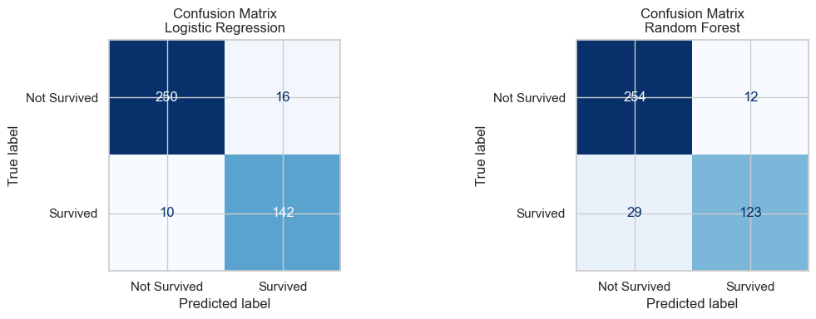

5.5 Feature Importances (Random Forest)
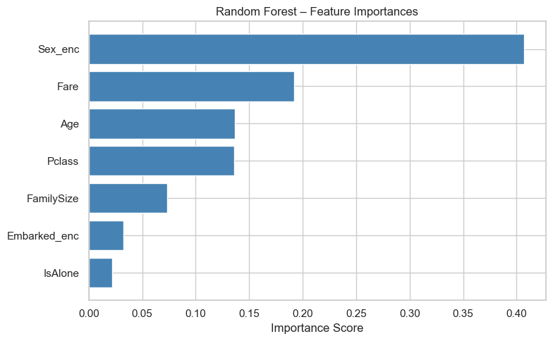
Sex is the most important feature by a wide margin, followed by Fare, Age, and Pclass. The engineered FamilySize feature also contributes meaningfully, suggesting that travelling alone or in large groups affected survival odds.

